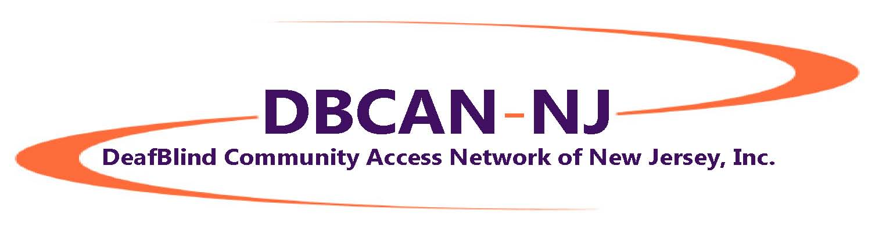
Spring Newsletter 2018

Contents

- DB CAN NJ Participates in Merck’s CapAbility Network
- Cornhole DOMination & Chili Cookoff – What a great day!
- Free SSPs for the Holidays Program
- Barnes & Noble Gift Wrapping
- Building Our SSP Team

DB CAN NJ Participates in Merck’s CapAbility Network
All we can say is WOW!! What a great day! On October 18, Scott Stoffel and his dad, Frank, came from West Chester, PA with three of Scott's Tactile Carnival games, and together with DB CAN NJ providing six volunteers, we all supported CapAbility Network, a diversity day at pharmaceutical giant Merck’s offices in Rahway, NJ. The goal of the day was to share DeafBlind culture and perspective, and to demonstrate alternative, tactile approaches. Volunteers included: Jon and Maria on BINGO, Chrissie (with Scott) on Touch Tetris, and Tara and Paul on Skeeball, and Kathy showed off our beginner braille curriculum. Merck was pleased with the positive feedback they received from their employees who came to play the tactile games and talk with the volunteers. The photo at right, which was also posted to the Merck website, shows, from left, Frank, Kathy, Diane and Kristy from Merck, Jon, Serena from Merck, Maria, Scott, Chrissie, Paul and Tara. Part of the Tetris game is at the bottom left, and the Skeeball game is shown diagonally from the left of the photo to the bottom right. We look forward to future collaborations with both Scott and Merck!

Cornhole DOMination and Chili Cook Off
Saturday, November 4: The weather was crisp and sunny, the chili was hot and spicy, the games were fun and competitive, and - best of all - everyone enjoyed themselves meeting new people, playing rousing games of Cornhole (beanbag toss), eating their fill (or maybe more!), and catching up with old friends and making new. In all, we raised about $900 for our Holiday SSPs program.
Cornhole DOMination and Chili Cookoff was held in memory and in honor of Dominick Leto, a young man who lost a courageous battle with cancer in February 2017. Upon his passing, Dom’s family asked that donations be made to DB CAN NJ. We were honored by their faith in us and their respect for the work that we do.
At the event on November 4, the Leto family presented a gorgeous set of handmade (by Mr. Leto and his daughter Michelle) teak Cornhole boards to the DeafBlind Champ, Jay. Jay was also the winner of the chili cook-off with his spicy Fighting Irish Chili. The following awards were presented to the winners:
Chili Champ: $25 ShopRite gift card & Chili Champ crown to Jay
Cornhole Champs: the team of Jay and Mike, each: $25 ShopRite gift card and Cornhole Champ crown, and the handmade Cornhole boards to Jay
Cornhole 2nd Place: the team of Alice and Ryan, each: $10 cash
Tournament champs: $20 cash to Mark and Nico
Many volunteered to make the day successful: Jeffrey and Paul took charge of the Cornhole games and brackets, Jon and Barbara set up the food, Maureen was the Chili vote counter and all-round helper with everything, Ken showed up early to help with the games, Kearny ShopRite donated funds used for food and gift cards, more than10 more people brought food and desserts, and many others offered throughout the day.
We hope that you’ll join us for the 2018 Cornhole! Be on the lookout for the date announcement soon!

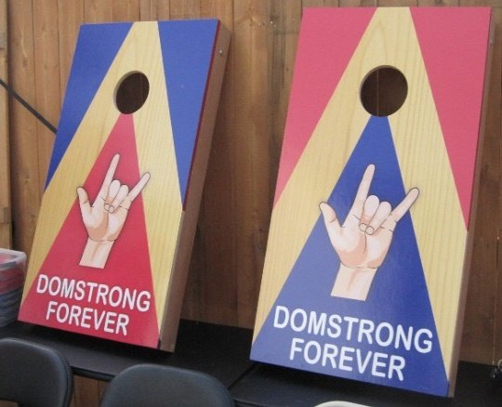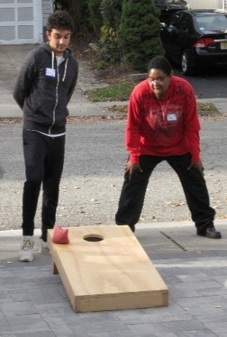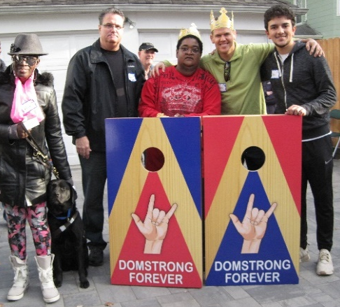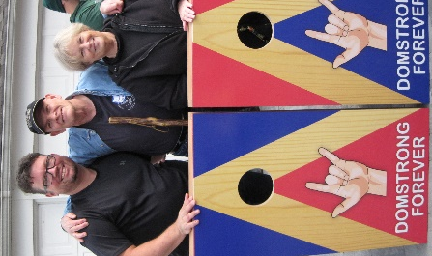

Free SSPs for the Holidays Program
DB CAN NJ offered three hours of FREE SSP services for use during December 2017. Eight DeafBlind people participated. Four of them decided to meet at the Menlo Park Mall on December 15, along with four SSPs and several friends. Altogether, we were a lively group of 11. The other four people decided to use their SSPs 1:1, at their homes or shopping locally. EVERYONE (yes, every one!) appreciated the SSP services. We hope to be able to offer more SSP services soon!

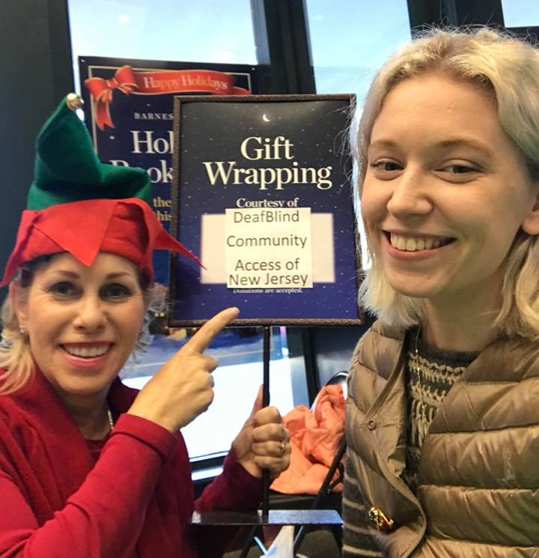
Barnes & Noble Gift Wrapping
For the first time, DB CAN NJ participated in holiday gift wrapping at Barnes & Noble, Clifton, NJ. Barnes & Noble invites nonprofits to volunteer to wrap customers’ purchases; in return, customers may make a donation to the organization. Thanks to Marci, Craig, Jon, Kathy, Kathy and Kristina for staffing our table on December 3 and 21. We raised $540 – pretty good for the first time! – and we look forward to continuing our relationship with Barnes & Noble in 2018.

Building Our SSP Team
We’re pleased to announce that DB CAN NJ is ready to build our SSP team! We are committed to providing the highest level of professional SSP services possible. To do our best to achieve that goal, our SSP training requirement is - at minimum - that each of our SSPs be trained by Allen, Jon, Mark or Kathy. If you are an SSP trained by Allen, Jon, Mark or Kathy OR if you would like to attend DB CAN NJ’s SSP training so that you can join us, please email dbcannj@gmail.com.

Like What You See Here?
Help us continue the great work we’re doing by making a tax deductible donation:
- Make your check payable to DeafBlind Community Access Network of New Jersey, Inc. and mail it to 359 Shadynook Street, Keypost, NJ 07735
- Go to the PayPal Giving Fund, https://www.paypal.com/fundraiser/hub, and type in DeafBlind Community Access Network of New Jersey, Inc.
- Send us your comments on this newsletter or anything that’s important to you and related to the DeafBlind community. Email your comments to: dbcannj@gmail.com

INFORMATION FILED WITH THE ATTORNEY GENERAL CONCERNING THIS CHARITABLE SOLICITATION AND THE PERCENTAGE OF CONTRIBUTIONS RECEIVED BY THE CHARITY DURING THE LAST REPORTING PERIOD THAT WERE DEDICATED TO THE CHARITABLE PURPOSE MAY BE OBTAINED FROM THE ATTORNEY GENERAL OF THE STATE OF NEW JERSEY BY CALLING 973-504-6215 AND IS AVAILABLE ON THE INTERNET AThttp://www.state.nj.us/lps/ca/charfrm.htm. REGISTRATION WITH THE ATTORNEY GENERAL DOES NOT IMPLY ENDORSEMENT.

Welcome Spring!
To be removed from this mailing list, please send an e-mail request to dbcannj@gmail.com

