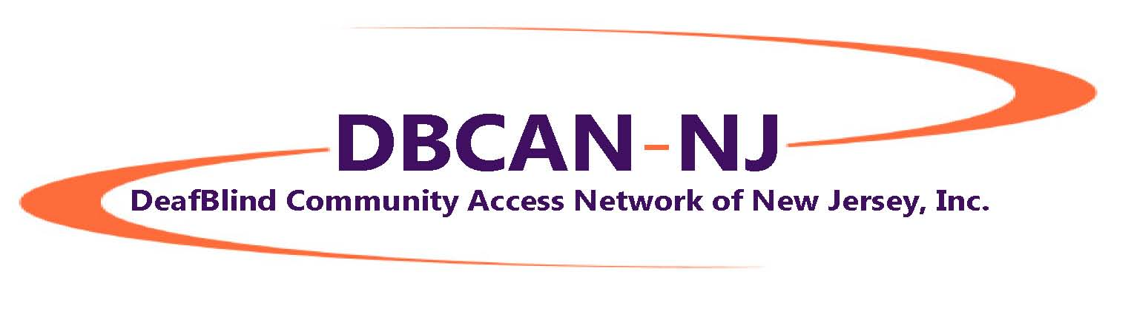
Spring Newsletter 2017

Contents

- BIG NEWS: We are an official nonprofit!
- Culture Encounters Event on March 11
- Dominick Leto Memorial Donations
- Recap: Taste of Technology
- Little Bits
- Like What You See Here?

BIG NEWS: We are an official Nonprofit!
The DeafBlind Community Access Network of New Jersey, Inc. has been approved by the Internal Revenue Service as a nonprofit agency! Nonprofit status means that now we can apply for grants to fund educational and social programs you have told us you want. At the top of our list for this year:
- SSP Services & Training
- DeafBlind Culture & Tactile Signing Training for interpreters, SSPs & Community Providers
- Mentor Program (matching families with children and DeafBlind adults)
- Peer SSP Program (for DeafBlind high school students)
We are so happy to be able to say: Your tax deductible contribution can be made through PayPal or by check payable to DeafBlind Community Access Network of New Jersey, Inc. and mailed to Paul Werner, Treasurer, 359 Shadynook Street, Keyport, NJ 07735

Thank you, everyone, for your support and belief in us!

Culture Encounters Event on March 11
On March 11, we hosted our first-ever Culture Encounters of the DeafBlind Kind event, and from all the positive reports we’ve received, we will be doing this event again (and again)! Culture Encounters of the DeafBlind Kind is an activity created by DB CAN NJ Board members. The activity is led by DeafBlind mentors with a goal of engaging the hearing and/or sighted community, SSPs and interpreters so that they have a better understanding of DeafBlind Culture.
In all, 35 people attended. Huge thanks to the team that pulled it together:
- Mark Gasaway, event coordinator
- Maria Martinez, volunteers coordinator
- Kathy Kady Hopkins provided lunch and acquired the Rutgers facility at no charge
- Marci Friedman and Kathy Gabry, co-hosts
- Mentors: Agatha, Jon, Craig, Chris, Mirellie, Betsy, Ed

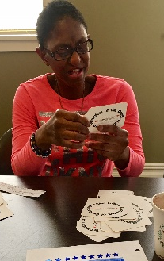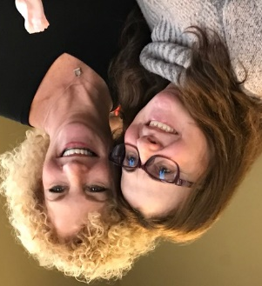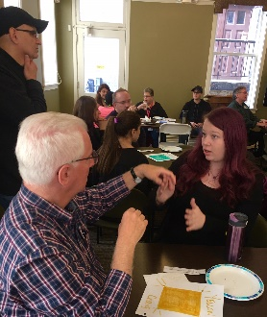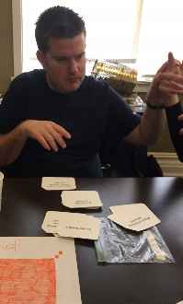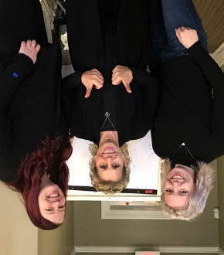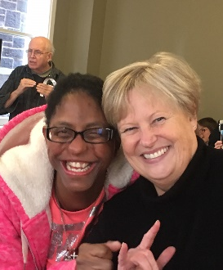

Dominick Leto Memorial Donations
On February 20, 2017, a young life was snuffed out too soon. Dominick Leto, 35, from Bergen County, New Jersey, passed away from cancer. Probably everyone in the New Jersey Deaf community knew Dom. He had an infectious smile and sense of humor.
Dom's family wanted his memory to live on through donations to an organization that was close to his heart, and they chose DB CAN NJ. Dom was good friends with Board member Paul Werner, Paul’s wife Tara, and Paul’s brother, Jeffrey.
It’s always hard to understand why an inspiring young life is taken too soon. Yet, in their grief, Dom's family hopes his memory will be shared and go on through the work of DB CAN NJ. All of us at DB CAN NJ are humbled by their faith in us, and are grateful to his family for believing in us. We will honor Dom’s legacy with an annual event, which is now in the planning stages.

Recap: Taste of Technology
With Sprint, we sponsored a Taste of Technology Seminar, Saturday, October 29, at Montclair State University. The goal of the conference was to raise awareness and understanding of new communications technologies available for those who are DeafBlind or have low vision.
About 180 people attended, including DeafBlind, family members and friends, sign language interpreters, support service providers, vendors and volunteers. Attendees traveled from as far away as the Netherlands, Massachusetts, Georgia and Virginia, as well as New Jersey and the New York metropolitan area.
Those completing conference satisfaction surveys said that they most appreciated the presentations by the speakers, the variety of topics, the knowledge gained regarding technology and the vendor booths they attended.
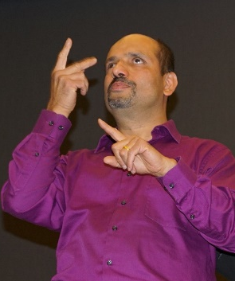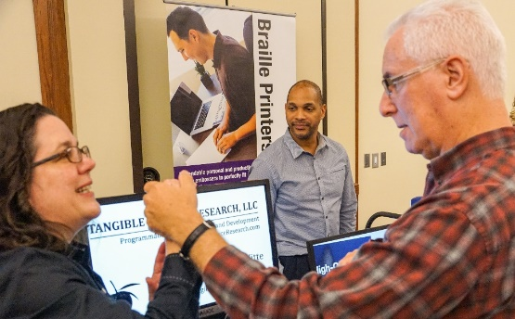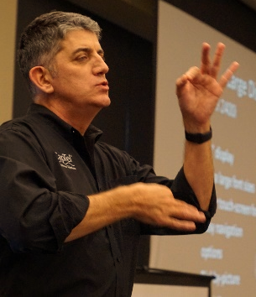

Little Bits
- Our Facebook page has been revised to reflect our status as a nonprofit! Please take a look, “like” us and leave us a comment!
- Thanks to Board Secretary Marci Friedman and Craig for staffing our table at UCC’s ASL Festival and spreading the word about us and our work.
- Feel free to send us your comments on this newsletter or anything that’s important to you and related to the DeafBlind community. Email your comments to: dbcannj@gmail.com

Like What You See Here?
Help us continue the great work we’re doing by making a tax deductible donation!
Send your check payable to DeafBlind Community Access Network of New Jersey, Inc. to 359 Shadynook Street, Keyport, NJ 07735

INFORMATION FILED WITH THE ATTORNEY GENERAL CONCERNING THIS CHARITABLE SOLICITATION AND THE PERCENTAGE OF CONTRIBUTIONS RECEIVED BY THE CHARITY DURING THE LAST REPORTING PERIOD THAT WERE DEDICATED TO THE CHARITABLE PURPOSE MAY BE OBTAINED FROM THE ATTORNEY GENERAL OF THE STATE OF NEW JERSEY BY CALLING 973-504-6215 AND IS AVAILABLE ON THE INTERNET AT http://www.state.nj.us/lps/ca/charfrm.htm. REGISTRATION WITH THE ATTORNEY GENERAL DOES NOT IMPLY ENDORSEMENT.

Welcome Spring! To be removed from this mailing list, please send an e-mail request to dbcannj@gmail.com

