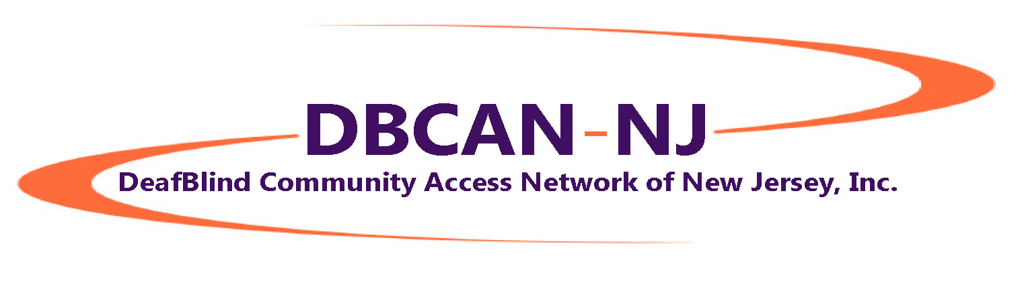
Summer Newsletter 2016
While it may seem like we've been quiet, DeafBlind Community Access Network of New Jersey, Inc. has been working behind the scenes to get all our nonprofit paperwork filed. This takes A LOT of time! BUT, once we get nonprofit status from the IRS, we can apply for funding to carry on our important work.
WE DO HAVE BIG NEWS: We are now fully incorporated as a nonprofit in the State of New Jersey!!
***********************************************************************************
Board News
We’ve decided to include people from across the country on our Board. Our reason for this is simple: We want to stay connected to all the important DeafBlind news, activities and issues important to our community. The new members of our Board are Mark Gasaway, from Georgia, and Jamie Pope, from Maryland. Both Mark and Jamie are DeafBlind and bring many years of advocacy and involvement in the DeafBlind community.
Our Board members are:
Kathy Gabry (NJ), President
Allen Reposh (NJ), Vice President
Marci Friedman (NJ), Secretary
Paul Werner (NJ), Treasurer
Mark Gasaway (GA), Board Member
Kathy Kady-Hopkins (NJ), Board Member
Jamie Pope (MD), Board Member

***********************************************************************************
With Sprint, we are sponsoring a Taste of Technology Seminar, Saturday, October 29 at Montclair State University. The Keynote speaker will be Bapin, the tech guru we all know and love from HKNC. We're pleased to have collaboration from the Helen Keller National Center and SSPNJ. Please make plans to join us!! You can register now at: www.njrelay.com/tot Click here to download a flyer
***********************************************************************************
Braille teacher Barbara Shalit and Kathy Gabry have been working to develop a curriculum to teach braille remotely - meaning that you can be in your home and Barbara can be in hers, and she'll able to teach you! If you're interested in learning braille this way, please e-mail dbcannj@gmail.com
***********************************************************************************
Hey - all of you interested in ProTactile Happy Hour!!! Who wants to travel to Baltimore for PTHH with our friend and Board member Jamie Pope?? This would mean one night in a hotel. You would need to pay for your own travel and accommodations, but we may be able to set up carpooling, or everyone could take the train together. Let us know if you're interested!
***********************************************************************************
Philly Touch Tours and our good friend Trish Maunder offer touch tours of interesting places in Philadelphia, such as the Italian Market. The Penn Museum, thanks to Trish, also has an amazing and totally hands-on tour of Ancient Egypt. Trish is able to get a bus to bring us from a meeting place in New Jersey to University of Pennsylvania in Philadelphia. Who wants to go?
***********************************************************************************
The International DeafBlind Expo is set for August 17 - 20 at the Rosen Hotel in Orlando. Please let us know if you're going!
***********************************************************************************
Who's interested in an ASL class?? Mary Ellen has graciously offered the use of her home in Little Falls for an ASL class. Cost will be $10 per class. Dates and times TBA.
***********************************************************************************
Is anyone interested in a series of yoga and nutrition workshops? Please let us know!
***********************************************************************************
Our Facebook page is up! So far, 73 people "Like" our page. Our goal is 1,000. Allen is our monitor. If you have something to share, please let us know so Allen can post it. AND we have 95 people on our mailing list. Please help us spread the word!!
***********************************************************************************
Have a safe and happy end of summer!
To be removed from this mailing list, please send an e-mail request to dbcannj@gmail.com

