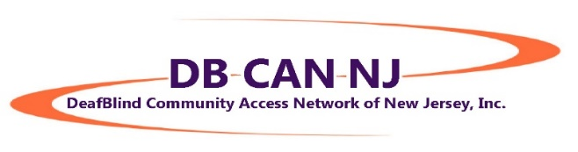
The Professional Access Provider

What is an Access Provider?
An Access Provider serves as a connection between someone who has a combined loss of hearing and sight and the surrounding environment.

What does the AP do?
The AP provides equal access to visual, situational and environmental information. The AP takes in information not seen or heard by the deafblind person and conveys it in an unbiased, objective manner.

The AP and the deafblind person form a trusting, interpersonal partnership that’s based on open, honest communication. This communication, as well as treating each other with mutual respect and dignity, are fundamental to the success of the partnership.

The AP works with one person at a time. In all, the AP does with, not for.

What are the qualifications to be an AP?
Necessary skills include the abilities to effectively communicate, to accurately and objectively describe the environment and situations, to provide safe and efficient human guide, to think on one’s feet, to easily adapt and to maintain personal boundaries.

Characteristics include keeping confidences, respecting and being willing to follow consumer choice, patience, flexibility, punctuality, and knowledge of and respect for DeafBlind culture.

When are services provided?
For any events and activities, or whenever the deafblind person requests – and receives approval for – their assistance.

Where?
Services are provided in home and community settings.

Why?
Professional APs are a connection to information. When DeafBlind people have information, they can make informed choices and decisions, more fully engage in their communities, communicate with others and, ultimately, enjoy life with greater freedom and independence.

How does this happen?
The partnership develops through mutual respect and is under direction of the deafblind person’s choices, decisions and leadership. The chart below describes the specifics of the role in more detail:

ROLE | RESPONSIBILITIES
Provide access to visual, situational and environmental information | - Objectively convey visual and/or auditory environmental information  - Relay certain aspects that are not seen or heard by the deafblind person (guidance provided by the deafblind individual)
Ensure comfortable and confident access to communication | - Provide assistance for short, social exchanges of spoken and/or signed conversations in home and community settings  - Use the deafblind person’s preferred language and communication mode to relay information as clearly and completely as possible  - Use facilitation mediums that may include sign language, spoken language, print, braille, touch/tactile (including Haptics and Pro-Tactile) or technology, among others
Provide safe and efficient access to the community | - Serve as a human guide  - Respect the mobility tools used by the person who is deafblind
Comply with preferred practices, ethics and professionalism of this developing field | - Work with one deafblind person at a time  - Respect the privacy, integrity and confidentiality of that individual  - Do with the deafblind person, not for  - Remain impartial and objective  - Recognize your own personal and physical limitations  - Maintain professional boundaries

© DBCANNJ 2019

