DeafBlind Awareness Series
June 2022
It’s DeafBlind Awareness Month! Our deafblind community told us that the goal of our DeafBlind Awareness activities this year should be to educate the larger community about being deafblind. We're all about being authentic, so the messages below are from our community. They provide explanations and words of wisdom to better understand the deafblind life experience.
Jeri Cooper: I would like people to know that we are people first! We have dreams, desires, abilities, wants, needs, shortcomings, strengths, emotions, likes and dislikes! Yes, we may have various methods of communication, but our minds and hearts are like yours!
Jon Gabry: I want people to know that I experience the world by touch through all my life. I use my hands to read braille, to explore 3D pictures and to discover different ways to make my 3D art. I also use my hands for communication using Tactile American Sign Language. Sometimes people use Haptics or Protactile to describe visual and environmental information on my back, leg or arm. Haptics helps me know what's going on around me or how the audience is behaving if I am giving a presentation. My long white cane helps me to travel safely and independently because I can feel surfaces and obstacles through the cane. Touch is my dependable sense.
Anne McQuade: I want people to know that DeafBlind people enjoy participating in the same activities as you do. However, we often have accessibility needs that a Provider (ex. Support Service Provider - SSP) will help meet. Please approach me any time. I’d be happy to discuss the activity I’m doing and answer any questions you may have.
Tara Lynn Invidiato: I want people to know that I may be totally deafblind but I’m not in a bind thanks to my technology. Technology has a heavy impact that gives optimistic possibilities towards independence and health. Using my iPhone, Mac computer and iPad with braille displays keeps me connected with the world. Through my fingertips, I can read news, check weather, write documents, use apps and chat with friends across the cyber realms. First, I learned braille and then how to use my technology – my “gadgets of hope.” This was a several years process with training provided by the Helen Keller National Center, Hadley School for the Blind, New Jersey State Commission for the Blind, the FCC’s iCanConnect technology program for deafblind, peers online and technology access websites. I’m always learning. With Bluetooth capabilities, deafblind people can be mindful of their health and achieve good self-care by also being able to monitor blood pressure, diabetes glucose monitoring and weight on their braille displays using any Apple products.
Patrick Markham: I want people to know that I can see, but I can’t. I have macular degeneration on my eyes.
Gavin Morrobel and Ethan Morrobel: We want people to know that few people are fully deaf and fully blind. Most have some residual sight and hearing. While partial vision or hearing can be useful, it can also be unreliable. It's helpful when you tell me who is in the room with me, or who has come into the room, what's going on (a dog wearing a fur collar is doing tricks!) and when you use directional terms (to our right) and measurements (about 5 steps ahead) instead of pointing and saying "over there."
Joe: I would like people to know that I suffered late hearing loss/deafness at age 35. I then became a cochlear implant recipient, which changed my life for the better. A cochlear implant is a small electronic device - a speech processor - attached directly to the hearing part of my brain. When people speak, it processes words, and that allows me to listen. I have helped five deaf individuals to learn more about cochlear implants and eventually say YES to choosing a cochlear implant. If anyone is interested in learning more about a cochlear implant, I would be happy to answer any questions. Please reach out to me through dbcannj@gmail.com. I am forever grateful for this technology that allows me to communicate and to stay safe.
Mark Gasaway: I want people to know that being DeafBlind brings challenges, which can help in the long run and benefit the person's life and lifestyle. My experience is that it teaches a person who’s deafblind how to learn and function in their own way. For example, I have never had the responsibility of actually driving a car. I did explore driving on country roads and around home, but had to stop because my visual field wasn’t good. That experience taught me I had to find other ways to get around. Such methods include walking, cycling, running and asking for rides, both free and paid, involving friends and family. It helped my lifestyle by opening doors to the unknown and solving problems in getting around, not to mention the exercise that came with walking, cycling and running. The exercise created health awareness which is still evident today. I was born hearing and sighted. When I became deafblind, losing my vision affected me more than losing my hearing.
Carol Thomas: I would like people to know that deafblind people are just like you. Someday, you may be one, too.
Alice Eaddy: I want people to know that DeafBlindness definitely isn’t about silence. I wish people would stop acting like being deafblind isn’t real with the unspoken assumption being that we have to be fakes because they can’t accept the fact that two disabilities can live in one body and not demoralize us or taint our love for life and simple pleasures.
Betsy: I would like people to know that even though I have two disabilities, there is nothing that I can’t do. Independence is my main priority, and I will do whatever’s necessary to achieve that goal. I live by myself, and I have a job that I love: being a braille instructor. I use many tools to help in my daily life. These include apps like AIRA and Be My Eyes that have someone look through your camera and give visual information to help with daily tasks. I will use Shipt that can go to the store and get me my groceries. I have also flown by myself relying on complete strangers for assistance. Also, I love listening to the New York Yankees baseball games on Alexa; she’s very informative.
DeafBlind Awareness Series 2022 – It’s a Wrap! DB CAN NJ is grateful to our community for sharing their personal messages with the wider community.
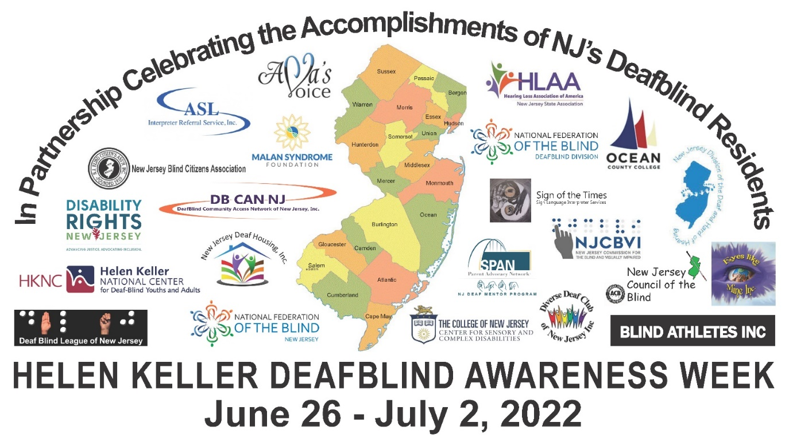
Graphic description: These words form an umbrella over 22 different logos: In Partnership Celebrating the Accomplishments of NJ’s Deafblind Residents. The 22 logos: ASL IRS, Ava’s Voice, Blind Athletes Inc, Center for Sensory & Complex Disabilities, DB CAN NJ, DeafBlind League of New Jersey, Disability Rights NJ, Diverse Deaf Club of New Jersey Inc., Eyes Like Mine Inc., Hearing Loss Association of America New Jersey State Association, Helen Keller National Center, Malan Syndrome Foundation, National Federation of the Blind DeafBlind Division, National Federation of the Blind of New Jersey, New Jersey Blind Citizens Association, New Jersey Council of the Blind, NJ Commission for the Blind, New Jersey Deaf Housing, New Jersey Division of the Deaf and Hard of Hearing, Ocean County College Sign Language Society, Sign of the Times Sign Language Interpreter Services, SPAN NJ Deaf Mentor Program. Under the logos, the text reads: Helen Keller Deafblind Awareness Week, June 26 – July 2, 2022

